**Assignment-6**

**AWS Architecture:**

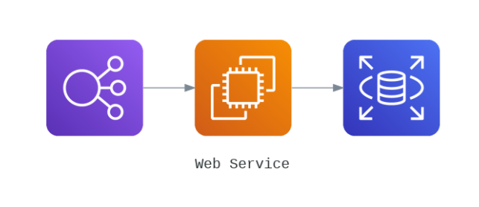

Here in the above diagram, it represents the elastic load balancer connected to an instance and that instance is connected to an RDS (relational database).

**Implementation:**

**Step 1:** I am going to launch two EC2 instances along with the hosting the simple web service on the both machines as THIS IS MACHINE 1 and THIS IS MACHINE 2

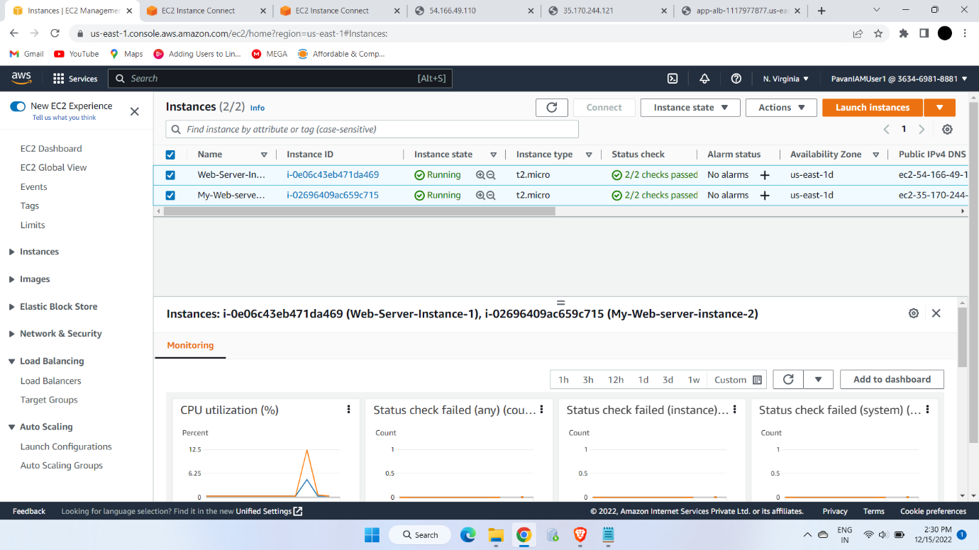

The above picture shows the two ec2 machines running successfully

I updated both the machines and launched the simple web services

**Step 2:** Now I created an Elastic Load Balancer to distribute the load among ec2 machines which are running.

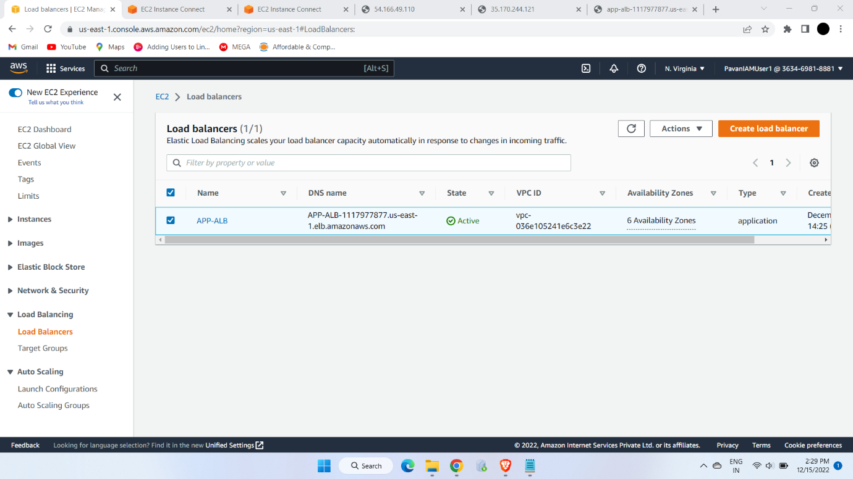

Now I made a connection with the two ec2 machines and Elastic Load Balancer which is working fine.

In APP-ALB I created a target group as TG-1 and checked all the AZs available.

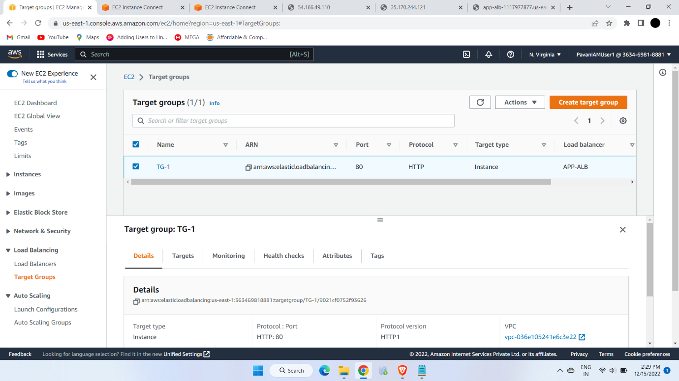

**Step 3:** Now I created a MySQL RDS and connected that one of the instances. In that I installed MySQL server and created a simple DB and created a simple table.

